**EXP 8: CREATE AVIRTUAL HARD DISK AND ALLOCATE THE STORAGEUSING VM WARE**

**WORKSTATION.DATE:30.09.2025**

**AIM:**

To create a virtual hard disk and allocate the storage using vm ware workstation

**PROCEDURE:**

STEP 1: GOTO VM WARE WORKSTATION.

STEP2: RIGHT CLICK THE VM AND GOTO THE SETTINGS.

STEP 3: ADD HARDWARE WIZARD AND SELECT SCSI AND CLICK NEXT.

STEP 4: CREATE NEW VIRTUAL DISK.

STEP 5: SELCT THE DISK SIZE AS 2.0. AND SELCT SPLIT VIRTUAL DISK INTOMULTIFILES.

STEP 6: GIVE NAME AND CLICK THE FINISH.

**IMPLEMENTATION:**

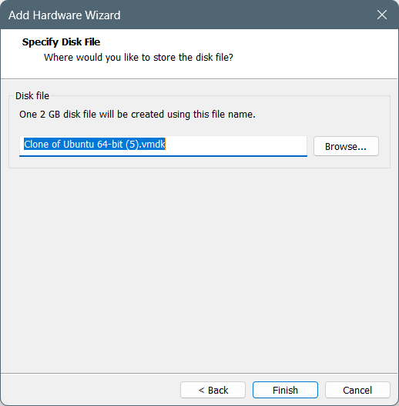

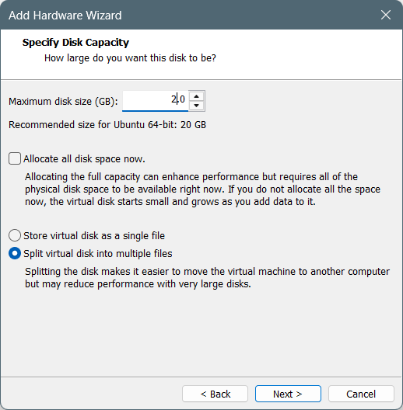

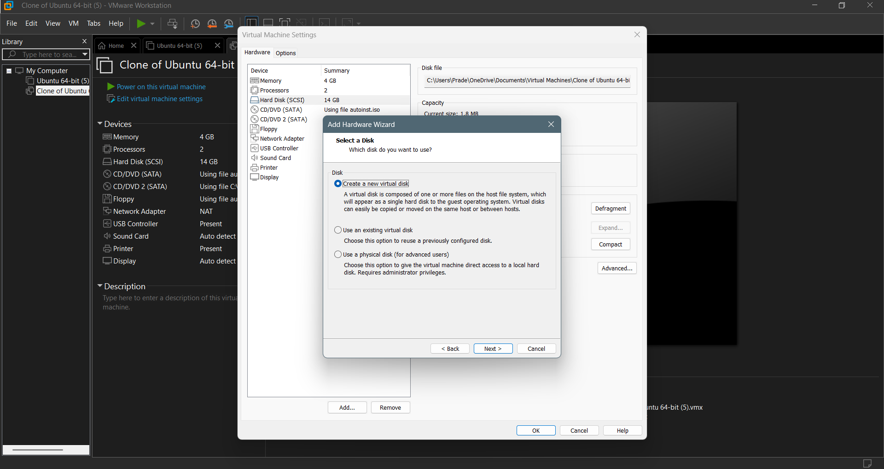

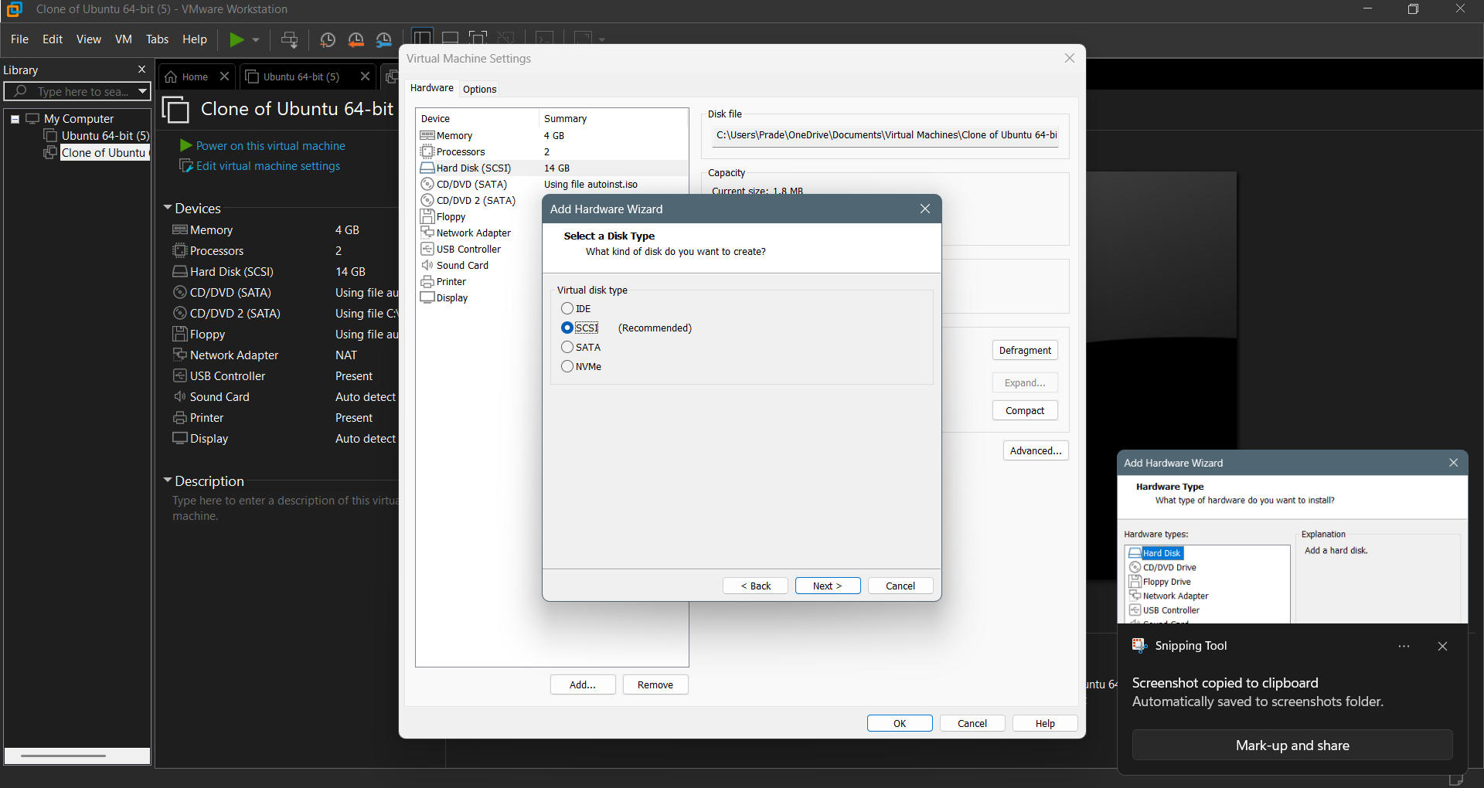

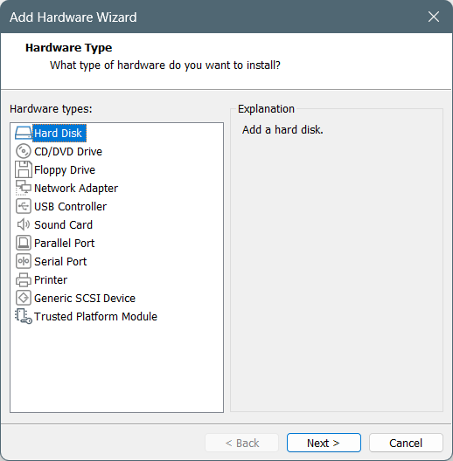

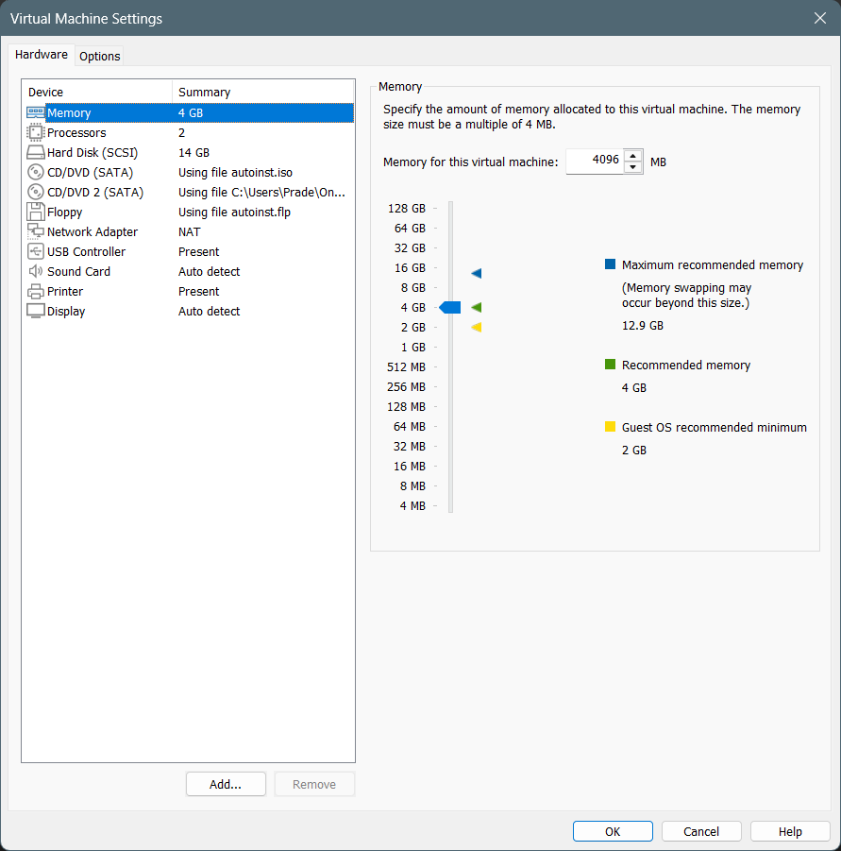

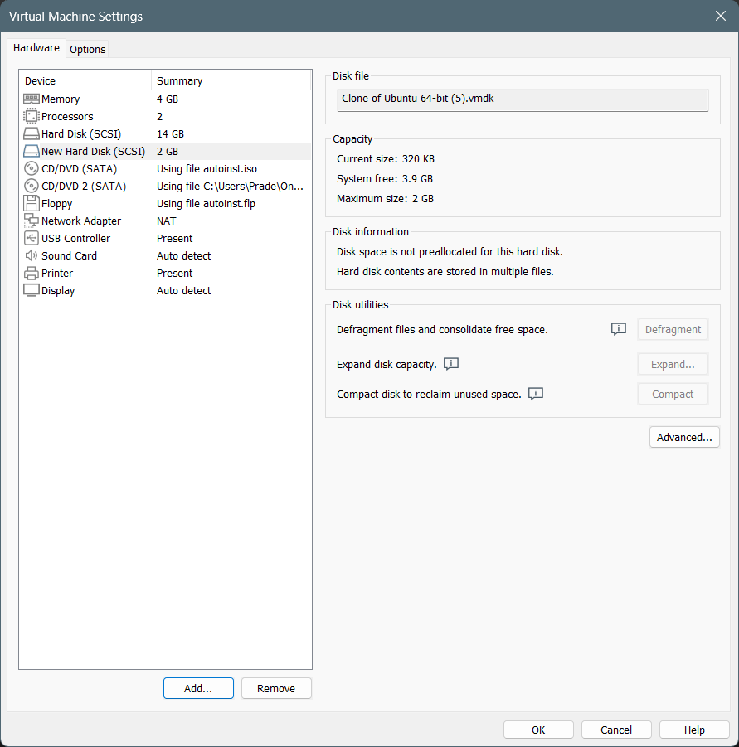

**RESULT:**

A virtual hard disk and allocate the storage using vm ware workstation has been created.